Module 1:

Locate an example of a misleading visual that uses one or more of the mechanisms for misleading that Cairo outlines in his book chapter:
- hiding relevant data,
- displaying too much data and obscuring reality,
- and distorting data through graphic forms

Tools for thinking about design (alberto cairo)

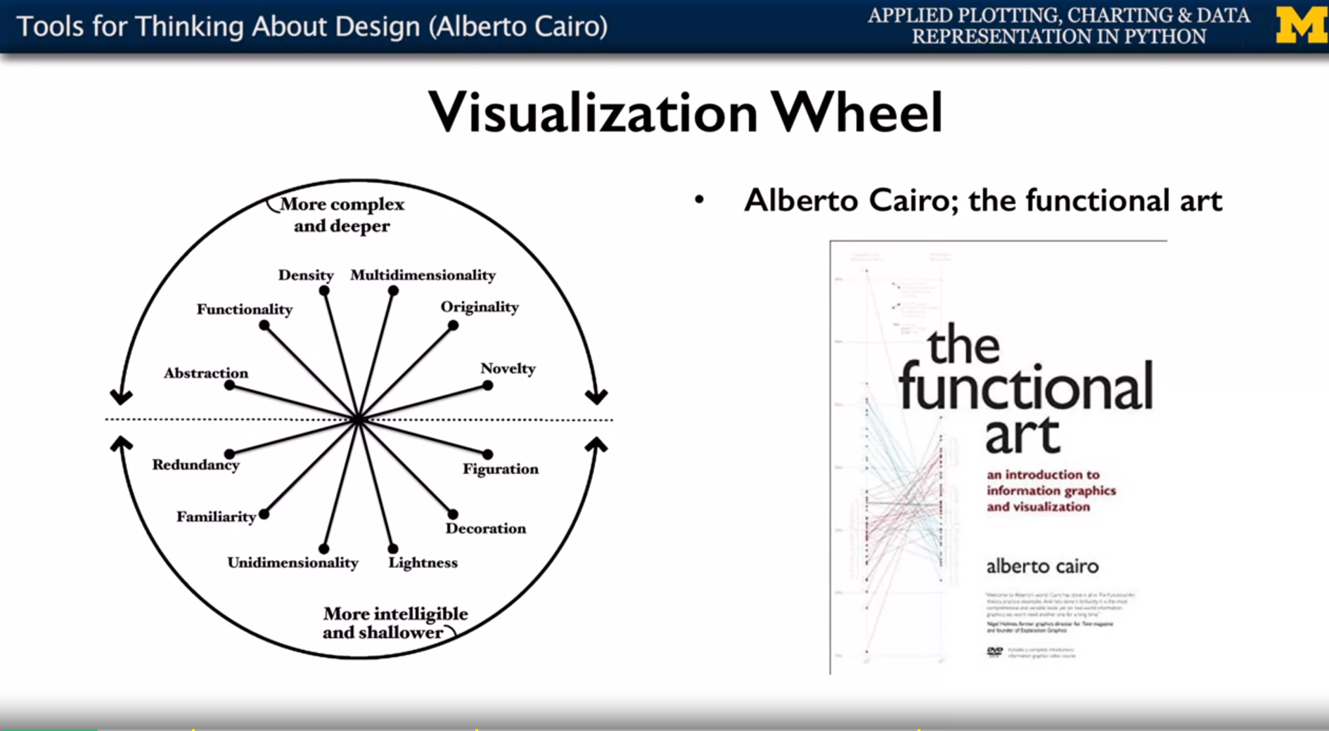

Role in organization might influence the kind of diagrams we create

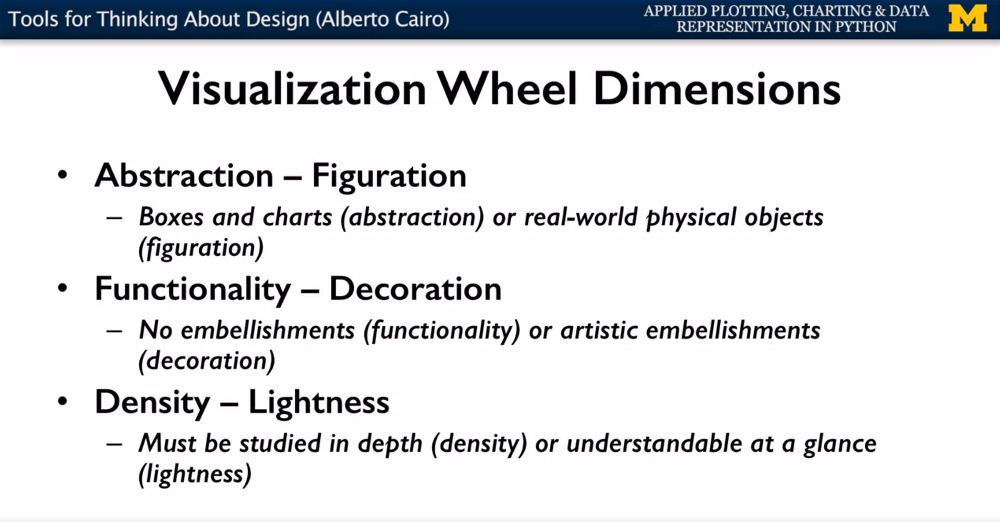

Module 3

